**Docker scout**

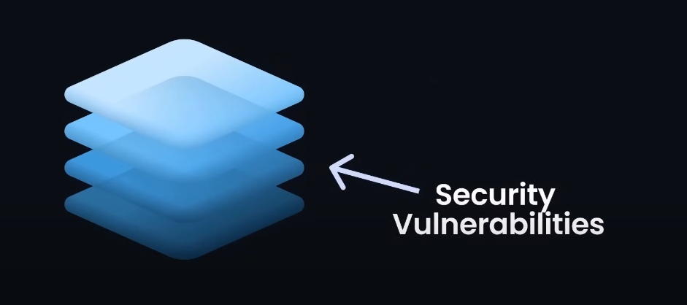

Basically when we are creating image, so every instruction in Image is like a layer.

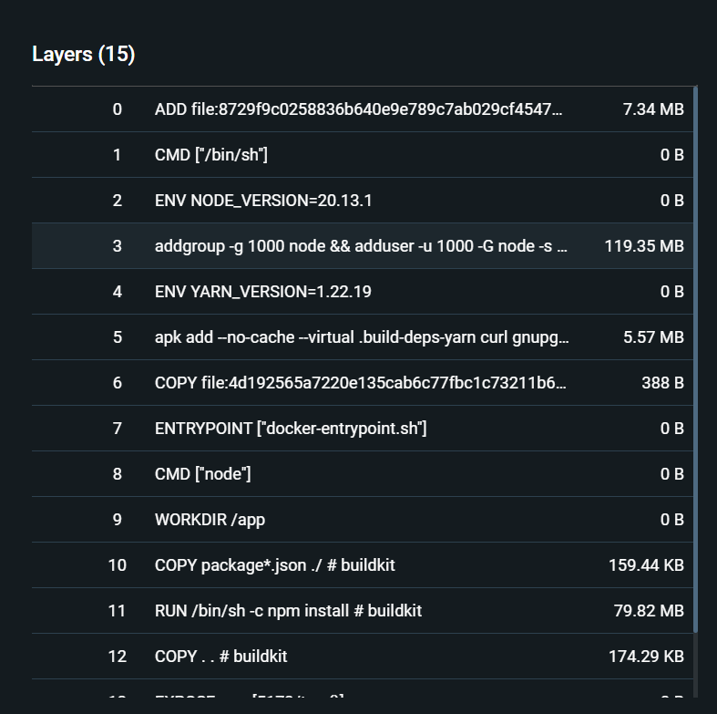

If you see the above pic so there you can see that Ek dockerfile may jitni be instruction likhi hai wo as a individual layer hain, Ab basically itni sari layers hain it is possible kay kisi be layer may **security vulnerability** (iska mtlb kay security weakness hoskti hai in any layer of our Image) So ab yeh weakness ko manually detect krna mushkil hai , SO then here comes **Docker Scout** it is a tool offered by Docker that can detect vulnerabilities (weaknesses) in our Image.

**How Docker Scout Work ?**

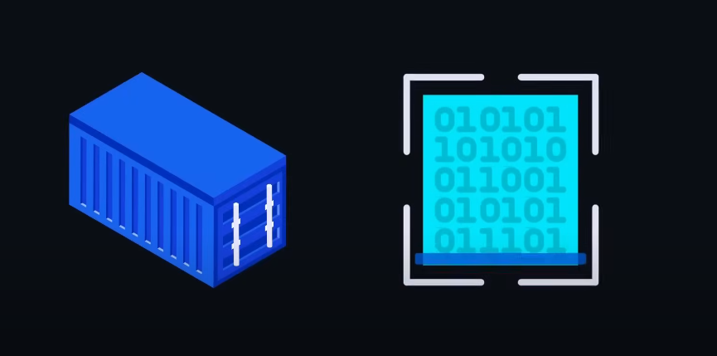

* it scan docker image and looks up all the layer of Image.



Then after scanning the whole image, it creates a detailed list of **Software Bill Od Material.**

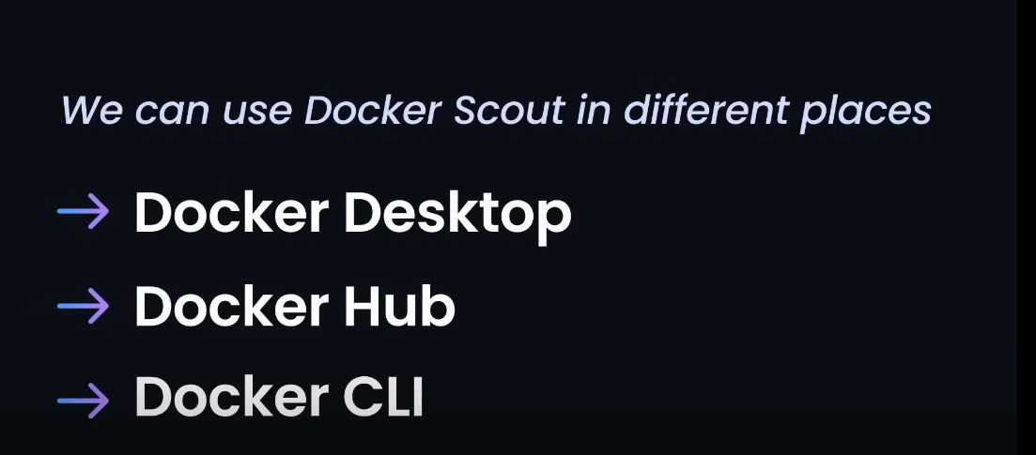

We can use Docker Scout at every place Docker desktop, docker Hub, and Docker CLI.